Opening of the Academic Year: Prayer for Students

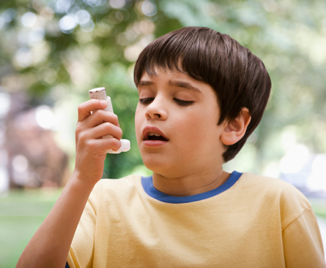
A School Parable: Christ’s living body active in our school
The teacher was in the middle of an Irish lesson one morning when the intercom broke the flow. Ciúnas descended as the class heard the urgency in the Principal’s voice apologising for interrupting classes.

‘This is an urgent message. Will a student in the first year area, who possesses an inhaler, please come to the front foyer immediately?’
Several boys were fast to react; ‘I have one Sir’ came the chorus of voices. ‘Only one is needed lads. Pádraig imigh leat ar luas a chara. Tá buachail i dtrioblóid éigin’, responded the teacher.
As the teacher opened the door and let Pádraig out he could see that what was happening in Room Four was also happening along the corridor. Like greyhounds out of traps in Shelbourne Park, inhaler-carrying students came running with intent from each room. All the boys continued to the foyer though it was obvious that only one was necessary to respond to the emergency.
Of course, each boy knew from personal experience what was at stake here. Each knew only too well that gasping for life-giving breath that some of us take for granted. Each wanted to be the saviour and it wouldn’t matter if it was friend or foe he was to save.
The ‘ciúnas’ was held in suspense till Pádraig returned to a communion not only restored, but deepened. The incarnation had just been played out in the corridors and foyer of this humble school. ‘Whatsoever you do to the least of these my little ones that you do unto me’.
In essence, it is love that is at the heart of both Eucharist and education. If education is to be understood more as lighting the fire of love rather than filling the bucket of information Eucharist needs to be understood as flux of life as well as ritual of sacrament. Anywhere bread is broken as forgiveness, understanding, even sharing an inhaler when a friend gasps for breath ...Christ is present.
As the hymn sings, ‘Let every breath, everything that I am never cease to worship You’. Christ’s living body is active in our school.
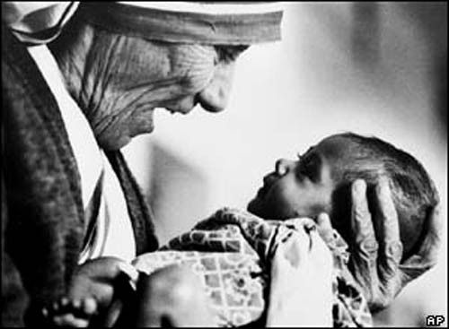
Whatsoever you do to the least of my brothers;
That you do unto me.
When I was hungry, you gave me to eat;
When I was thirsty, you gave me to drink.
Now enter into the home of My Father.
Whatsoever you do to the least of my brothers;
That you do unto me.
When I was homeless, you opened your door;
When I was naked, you gave me your coat.
Now enter into the home of My Father.
Whatsoever you do to the least of my brothers;
That you do unto me.
When I was weary, you helped me find rest.
When I was anxious, you calmed all my fears.
Now enter into the home of My Father.
Whatsoever you do to the least of my brothers
That you do unto me.

Prayer of St. Therese
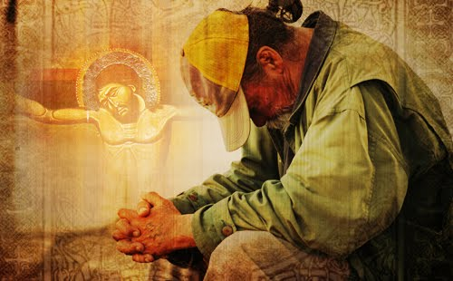
Christ has no body but yours,
No hands, no feet on earth but yours,
Yours are the eyes with which he looks
Compassion on this world,
Yours are the feet with which he walks to do good,
Yours are the hands, with which he blesses all the world.
Yours are the hands, yours are the feet,
Yours are the eyes, you are his body.
Christ has no body now but yours,
No hands, no feet on earth but yours,
Yours are the eyes with which he looks
compassion on this world.
Christ has no body now on earth but yours.

Concluding Prayer: All
In our school Lord be glorified, be glorified
In our students Lord be glorified, be glorified today
In our study Lord be glorified, be glorified
In our play Lord be glorified, be glorified today
In our successes and mistakes Lord be glorified be glorified
In our school Lord be glorified be glorified today. Amen

Footnote: the above School Parable actually happened but we must be mindful that school health and safety policies may now insist that students with asthma are obliged to have a spare inhaler at all times in the school.

