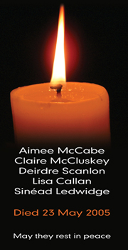

NAME
Died:
Rest In Peace

